UNIT 8: Code Debugging and Error Handling

1. Syntax Errors
A Syntax Error occurs when the rules of the programming language are not followed while writing the code.
Every programming language has a specific syntax (grammar) that must be followed. If the syntax is wrong, the program will not run.
The compiler or interpreter detects syntax errors before executing the program.
Common Causes of Syntax Errors
- Missing semicolon or bracket
- Incorrect spelling of keywords
- Missing quotation marks
- Incorrect indentation (in languages like Python)
- Using wrong operators
Example (C Language)
Incorrect Code:
#include <stdio.h>
int main()
{
printf("Hello World")
return 0;
}
Error: Missing semicolon after the printf statement.
Correct Code:
#include <stdio.h>
int main()
{
printf("Hello World");
return 0;
}
Characteristics of Syntax Errors
- Detected before execution
- Easy to fix
- Usually shown with an error message
2. Runtime Errors
A Runtime Error occurs while the program is running. The program compiles successfully but crashes during execution.
These errors happen due to invalid operations performed by the program.
Common Causes of Runtime Errors
- Division by zero
- Accessing invalid memory location
- Opening a file that does not exist
- Overflow or underflow
- Using uninitialized variables
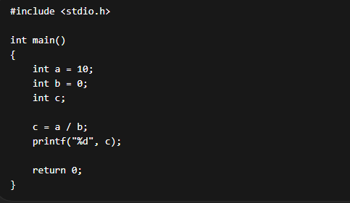
Here, the program compiles correctly but crashes because division by zero is not allowed.
Characteristics of Runtime Errors
- Occur during program execution
- Harder to detect than syntax errors
- May cause program crash

3. Logical Errors
A Logical Error occurs when the program runs without crashing but produces incorrect output.
These errors happen due to wrong logic in the program.
Example
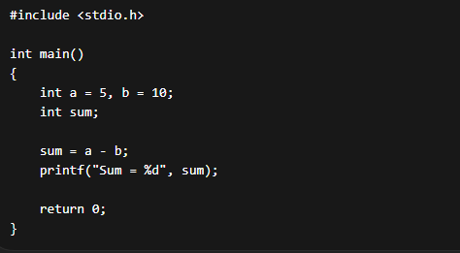
Correct code : sum = a + b;
Characteristics of Logical Errors
- Program runs successfully
- No error message is shown
- Output is incorrect
- Hardest to detect
4. Debugging Techniques
Debugging is the process of finding and fixing errors in a program.
Programmers use different techniques to identify problems in code.
Common Debugging Techniques
1. Print Statement Debugging
- Add print statements to check values of variables.
ex - printf("Value of a = %d", a);
2. Step-by-Step Execution
- Execute the program line by line to see where the error occurs.
3. Using Debugger Tools
- Tools like GDB, Visual Studio Debugger help detect errors.
4. Checking Logic
- Review the algorithm and logic carefully.
5. Testing with Different Inputs
- Use multiple test cases to check program behavior.

5. Dry Run and Tracing
Dry Run
A Dry Run means manually executing the program step by step without using a computer to understand how the program works.
It helps in identifying logical errors.
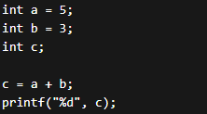
Dry Run Table
Step | a | b | c
Initial | 5 | 3 | -
After calculation | 5 | 3 | 8
Output = 8
Tracing :
Tracing means tracking the values of variables during program execution.
It helps in understanding how the data changes during the program.
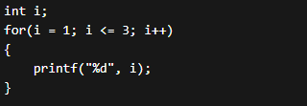
Iteration | i | Output
1 | 1 | 1
2 | 2 | 2
3 | 3 | 3

6. Common Programming Mistakes
Programmers often make certain common mistakes while coding.
1. Missing Semicolons
printf("Hello")
2. Wrong Variable Type
int a;
a = 10.5;
3. Infinite Loops
while(1)
{
}
4. Wrong Condition in If Statement
if(a = 5)
Instead of
if(a == 5)
5. Uninitialized Variables
int x;
printf("%d", x);
6. Off-by-One Errors
Example
for(i = 0; i <= 10; i++)
Sometimes the correct loop should be
for(i = 0; i < 10; i++)

